
Semester One Examination, 2021

Question/Answer Booklet

MATHEMATICS

SOLUTIONS
METHODS
ATAR Year 12
Section One:
Calculator-free

Student Name: ______________________________________________________

Please circle your teacher’s name
Teacher: Miss Hosking Miss Rowden

Time allowed for this paper
Reading time before commencing work: 5 minutes
Working time for paper: 50 minutes

Materials required/recommended for this paper
To be provided by the supervisor
Number of additional
answer booklets used
(if applicable):
This Question/Answer Booklet
Formula Sheet

To be provided by the candidate
Standard items: pens (blue/black preferred), pencils (including coloured), sharpener, correction fluid/tape, eraser, ruler, highlighters

Special items: nil

Important note to candidates
No other items may be taken into the examination room. It is your responsibility to ensure that you do not have any unauthorised material. If you have any unauthorised material with you, hand it to the supervisor before reading any further.
Structure of this paper
Section | Number of questions available | Number of questions to be answered | Suggested working time (minutes) | Marks available | Percentage of examination
Section One:  Calculator free | 8 | 8 | 50 | 52 | 35
Section Two:  Calculator-assumed | 13 | 13 | 100 | 98 | 65
 |  |  |  | Total | 100

Instructions to candidates
- The rules for the conduct of the ATAR course examinations are detailed in the Year 12 Information Handbook 2021. Sitting this examination implies that you agree to abide by these rules.

- Write your answers in this Question/Answer booklet.

- You must be careful to confine your answers to the specific questions asked and to follow any instructions that are specific to a particular question.

- Supplementary pages for the use planning/continuing your answer to a question have been provided at the end of the Question/Answer booklet. If you use these pages to continue an answer, indicate at the original answer where the answer is continued, i.e. give the page number.

- Show all your working clearly. Your working should be in sufficient detail to allow your answers to be checked readily and for marks to be awarded for reasoning. Incorrect answers given without supporting reasoning cannot be allocated any marks. For any question or part question worth more than two marks, valid working or justification is required to receive full marks. If you repeat any question, ensure that you cancel the answer you do not wish to have marked.

- It is recommended that you do not use pencil, except in diagrams.

- The Formula sheet is not to be handed in with your Question/Answer booklet.

Section One: Calculator-free 35% (52 Marks)

This section has eight (8) questions. Answer all questions. Write your answers in the spaces
provided.

Supplementary pages for the use of planning/continuing your answer to a question have been provided at the end of this Question/Answer booklet. If you use these pages to continue an answer, indicate at the original answer where the answer is continued, i.e. give the page number.

Working time: 50 minutes.

Question 1 (6 marks)
(a) Determine $\begin{matrix}d \\ \overline{dx}\end{matrix}\left(\cos^{4}{(x)}\right)$. (2 marks)
Solution
$$-4\sin{x}\cos^{3}{x}$$

Specific behaviours
indicates use of chain rule
ü correct derivative

(b) Evaluate $f'\left(\frac{π}{2}\right)$ when $f\left(x\right)=\begin{matrix}x+\sin{x} \\ \overline{ \cos{2x} }\end{matrix}$ . (4 marks)
Solution
$$f^{'}\left(x\right)=\frac{\left(1+\cos{x}\right)(\cos{2x})-(x+\sin{x})(-2\sin{2x})}{\cos^{2}{2x}}$$

$$f^{'}\left(\frac{π}{2}\right)=\frac{\left(1+0\right)\left(-1\right)-0}{{\left(-1\right)}^{2}} \\ =-1$$

Specific behaviours
indicates use of quotient rule
ü correct $u'$ and $v'$
ü correct derivative
ü substitutes and simplifies

Question 2 (5 marks)
A small body is initially at the origin. It is moving along the $x$-axis with velocity at time $t$ seconds given by
$$v\left(t\right)={\left(\frac{t}{2}-2\right)}^{3} \text{cm/s}.$$

(a) Determine $x(t)$, a function for the displacement of the body at time $t$. (3 marks)
Solution
$$x\left(t\right)=\int{{\left(\frac{t}{2}-2\right)}^{3}}dt \\ =\frac{2}{4}{\left(\frac{t}{2}-2\right)}^{4}+c$$

$$t=0⇒\frac{1}{2}{\left(-2\right)}^{4}+c=0⇒c=-8$$

$$x\left(t\right)=\frac{1}{2}{\left(\frac{t}{2}-2\right)}^{4}-8$$

Specific behaviours
reasonable attempt at using chain rule
ü correct antiderivative
ü correct displacement function

The small body is stationary when $t=T$.

(b) Determine the displacement of the body at $T+8$ seconds. (2 marks)
Solution
$$\frac{T}{2}-2=0⇒T=4 \text{s}$$

$$x\left(12\right)=\frac{1}{2}{\left(4\right)}^{4}-8 \\ =\frac{1}{2}(256)-8 \\ =120 \text{cm}$$

Specific behaviours
correct value of $T$
ü correct displacement

Question 3 (6 marks)
Determine the area of the finite region bounded by $y=\sqrt{2x}$ and $y=\begin{matrix}x \\ \overline{2}\end{matrix}$.
Solution
Points of intersection:
$$\sqrt{2x}=\frac{x}{2} \\ x^{2}-8x=0 \\ x=0, x=8$$
Area:
$$A=\int_{0}^{8}{\sqrt{2x}-\frac{x}{2}}dx \\ ={\left[\frac{{\left(2x\right)}^{\frac{3}{2}}}{3}-\frac{x^{2}}{4}\right]}_{0}^{8} \\ =\left[\frac{{\left(16\right)}^{\frac{3}{2}}}{3}-\frac{8×8}{4}\right]-0 \\ =\frac{64}{3}-16 \\ =\frac{16}{3} {\text{u}}^{2}$$

Specific behaviours
equates curves and squares
ü points of intersection
ü writes integral for area
ü correct antiderivative
ü substitutes
ü simplifies to obtain area

Question 4 (8 marks)
(a) Simplify $\log_{2}{(32)}×\log_{3}{({27}^{2})}$. (3 marks)

Solution
$$\log_{2}{2^{5}}×\log_{3}{3^{6}}=5×6=30$$

Specific behaviours
expresses as powers of log bases
✓ uses log law of log_{a}a = 1
✓ simplifies

(b) Solve for $x$:

- $\log_{2}{\frac{x}{3}=4}$ (2 marks)

Solution
$2^{4}=\frac{x}{3}$
$16=\frac{x}{3}$
$x=48$

Specific behaviours
rewrites log into index form
ü correct solution for x

- $\log_{m}{(x+2)}-\log_{m}{4= \log_{m}{3x}}$ (3 marks)

Solution
$\log_{m}{\frac{(x+2)}{4}}= \log_{m}{3x}$
$\frac{x+2}{4}= 3x$
$$x+2= 12x$$
$$2= 11x$$
$x= \frac{2}{11}$

Specific behaviours
simplifies LHS using log laws
ü equates
ü correctly solves for x

Question 5 (8 marks)
(a) Sketch the graph of $y=\log_{3}{(x+3)}-1$ on the axes below, clearly showing the location of all asymptotes and axes intercepts. (3 marks)
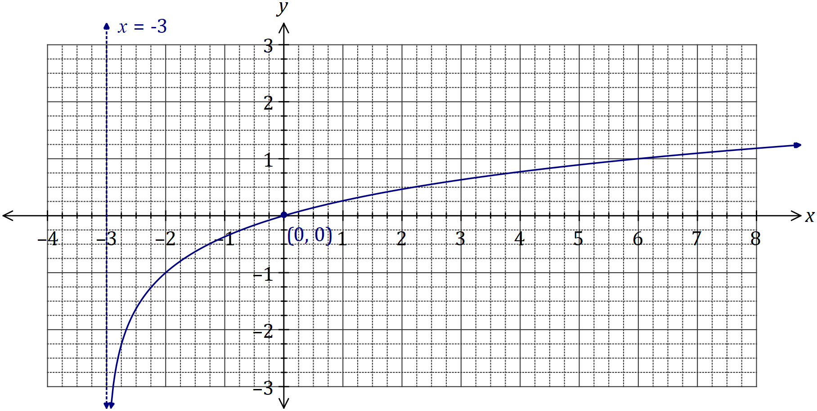
Solution
See graph
Specific behaviours
asymptote
✓ root at $x=0$
✓ curve, through $(-2,-1)$ and $(6, 1)$

(b) Determine the coordinates of the $y$-intercept of the graph of $y=5\log_{2}\left(x+0.5\right)+1$.
(2 marks)
Solution
$$y=5\log_{2}\left(0.5\right)+1=5\log_{2}\left(2^{-1}\right)+1=-5+1=-4$$

$$\text{At} \left(0, -4\right)$$

Specific behaviours
simplifies log term to $-1$
✓ states coordinates of root

(c) The graph of $y=\log_{a}{(x+a)}$, where $a>1$, passes through $(6, 2)$. Determine the coordinates of the root of the graph. (3 marks)
Solution
$$2=\log_{a}\left(6+a\right)⇒a^{2}-a-6=0$$

$$\left(a-3\right)\left(a+2\right)=0 \\ a=3 or-2$$
$$a=3, \left(a>1\right)$$

$$\text{Hence root at} (-2, 0)$$

Specific behaviours
forms quadratic equation
✓ solves for $a$ with both solutions, then rejects -ve
✓ states coordinates of root

Question 6 (5 marks)
(a) Determine $\begin{matrix}d \\ \overline{dx}\end{matrix}\left(3x∙\sqrt[3]{e^{x}}\right)$. (2 marks)

Solution
$$\frac{d}{dx}\left(3x∙e^{\frac{x}{3}}\right)=3e^{\frac{x}{3}}+xe^{\frac{x}{3}}$$

Specific behaviours
uses product rule
ü obtains correct result

(b) Hence, or otherwise, determine $\int_{ }^{ }{\underset{ }{\overset{ }{\left(3x∙\sqrt[3]{e^{x}} \right)}}}dx$. (3 marks)
Solution
$$\int{\frac{d}{dx}\left(3x∙e^{\frac{x}{3}}\right)}dx=\int{3e^{\frac{x}{3}}}dx+\int{xe^{\frac{x}{3}}}dx$$

$$3xe^{\frac{x}{3}}=9e^{\frac{x}{3}}+\int{xe^{\frac{x}{3}}}dx$$

$$3\int{xe^{\frac{x}{3}}}dx=\int{\left(3x∙\sqrt[3]{e^{x}}\right)}dx=9xe^{\frac{x}{3}}-27e^{\frac{x}{3}}+c$$

Specific behaviours
integrates all terms of result from (a)
ü uses fundamental theorem to simplify LHS
ü obtains required result, with constant

Question 7 (6 marks)
The shaded region $R$, shown on the graph below, is bounded by the curve $y=e^{3x}$ and the lines $y=0, x=0$ and $x=a$.

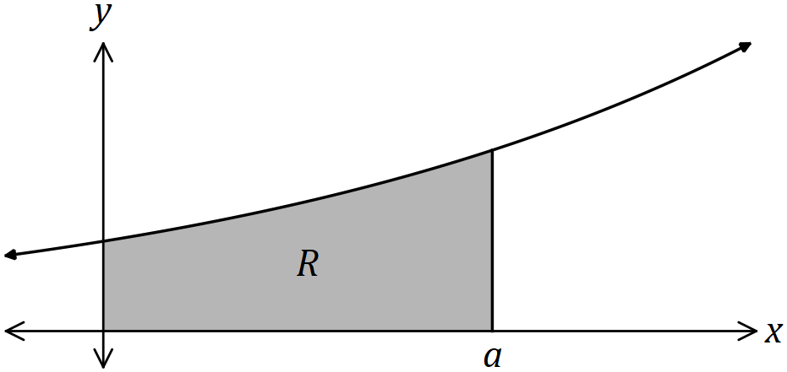

(a) Determine the area of $R$ in terms of $a$. (3 marks)
Solution
$$R=\int_{0}^{a}{e^{3x}}dx \\ ={\left[\frac{e^{3x}}{3}\right]}_{0}^{a} \\ =\frac{e^{3a}}{3}-\frac{e^{0}}{3}=\frac{e^{3a}}{3}-\frac{1}{3}$$

Specific behaviours
✓ writes correct integral
antidifferentiates correctly
✓ substitutes and simplifies

(b) Determine, in simplest form, the value of $a$ for which the area of $R$ is $21$ square units.
(3 marks)
Solution
$$\frac{e^{3a}}{3}-\frac{1}{3}=21⇒e^{3a}=64$$

$$\log{e^{3a}}=log{64}$$

$$3a\log{e}=log{64}$$
$$a=\frac{\log{64}}{3\log{e}}$$

Specific behaviours
isolates $e^{3a}$ term
✓ uses logs to obtain expression for $a$
✓ simplifies

Question 8 (8 marks)
The function $f$ is defined by $f\left(x\right)=\begin{matrix}4 \\ \overline{x^{2}+12}\end{matrix}$ , so that $f^{''}\left(x\right)=\begin{matrix}24(x^{2}-4) \\ \overline{ {\left(x^{2}+12\right)}^{3} }\end{matrix}$.
(a) Describe the concavity of the graph of $y=f(x)$. (4 marks)

Solution
$$f^{''}\left(x\right)=0⇒x^{2}-4=0⇒x=±2$$

$$x<-2, f^{''}\left(x\right)>0 \\ -2<x<2, f^{''}\left(x\right)<0 \\ x>2, f^{''}\left(x\right)>0$$

$f$ is concave up when $x<-2$ and $x>2$.
$f$ is concave down when $-2<x<2$.

Specific behaviours
solves $f^{''}\left(x\right)=0$
ü indicates sign of $f''(x)$ in three intervals
ü states domains for concave up, down
ü uses correct inequalities in domains
(penalise ambiguous language such as between $-2$ and $2$, etc.)

(b) Determine, with justification, the range of $f'(x)$. (4 marks)
Solution
$$f^{'}\left(x\right)=\frac{-8x}{{\left(x^{2}+12\right)}^{2}}$$

As $x→±∞, f^{'}\left(x\right)→0$.

Minimum and maximum of $f'(x)$ will be when its derivative ${f'}^{'}\left(x\right)=0$, (i.e., at points of inflection) and from part (a) this is when $x=±2$.

$$f^{'}\left(±2\right)=±\frac{-8×2}{16×16}=∓\frac{1}{16}$$

Hence the range is:
$$-\frac{1}{16}≤f^{'}\left(x\right)≤\frac{1}{16}.$$

Specific behaviours
expression for $f'(x)$
ü states behaviour of $f'(x)$ for $x→±∞$
ü location of minimum and maximum values of $f'(x)$
ü correct range, as inequality

Supplementary page

Question number: _____________________

Supplementary page

Question number: _____________________

